PAST SIMPLE OR PAST CONTINUOUS
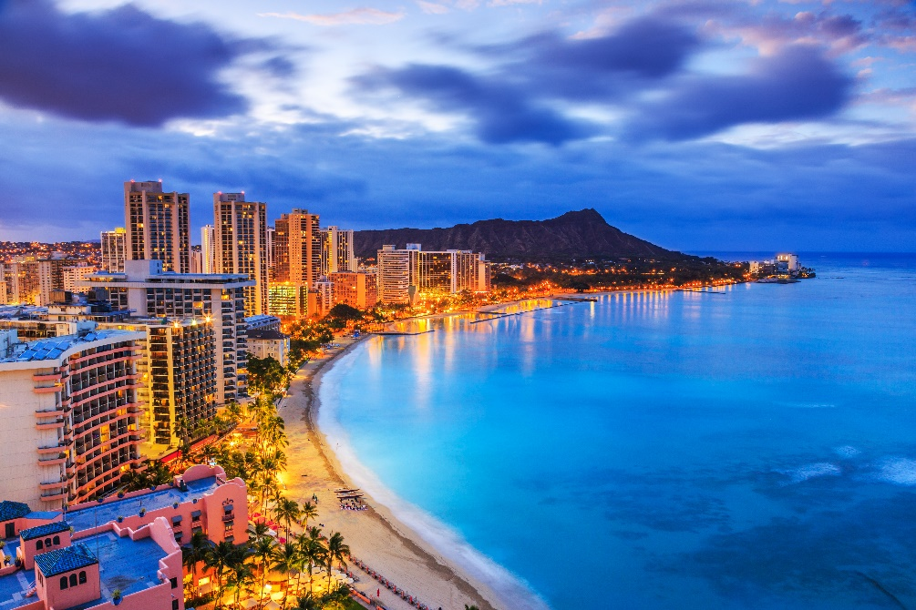
Fill the sentences with the Past Simple or Past Continuous form of the verbs in brackets.

Greetings from Hawaii

I always wanted to visit Hawaii and last year I finally ________________ (get) the chance to go there.
I ________________ (fly) there, of course. The islands ________________ (look) so beautiful from the plane, I was amazed.
As the plane ________________ (land), I ________________ (think) about the great time I’d have there. When I ________________ (step out) of the plane,
I ________________ (feel) the sun on my face, but I ________________ (not hear) anything but the noises of the busy airport.
I ________________ (take) the taxi to the hotel I booked earlier.
When I ________________ (get) there, I was shocked because
it ________________ (be) a huge skyscraper. I ________________ (expect) something much smaller, surrounded by palm trees. But I ________________ (not let) myself be disappointed – I ________________ (come) to enjoy the sea, the beaches, the nature.
So, I quickly ________________ (unpack), ________________ (put on) my swimsuit and ________________ (head off) to the beach for some peace and quiet.
I ________________ (cannot) be more wrong! The beach was packed with people!
The children ________________ (run around) and ________________ (scream) loudly. Some people ________________ (play) beach volleyball while
others ________________ (cheer). And that was just the beginning of the worst holiday of my life.

WILL FUTURE OR GOING TO FUTURE
Fill the sentences with the Will Future or Going to Future form of the verbs in brackets.

1 A: Do you have any plans for the weekend?
B: Oh yes! I ____________________ (visit) my grandparents in Osijek.

2 A: Why are you so sad?
B: I think I ____________________ (fail) the exam.

3 Mum, can I go out with John? I promise I ____________________ (come back) by 9!

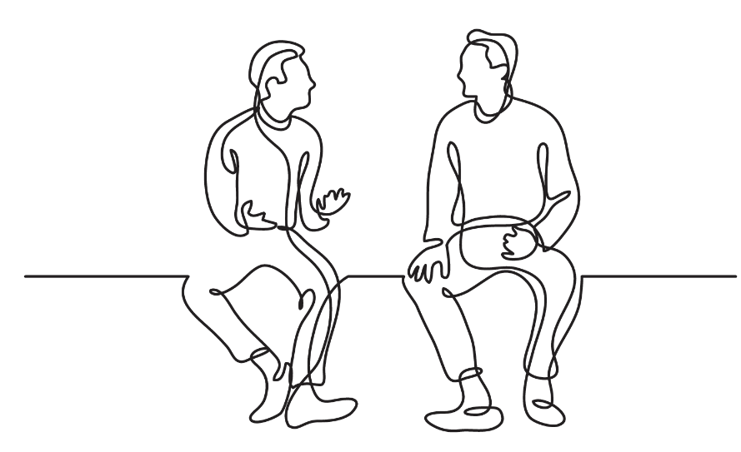
4 Next month Susan ____________________ (start) learning Italian. She’s already paid for the course.

5 A: Mum, can you make us a cake?
B: Sorry, boys, I can’t. I haven’t got any milk.
A: We ____________________ (go) to the shops and buy some!

6 I’ve finally made a great plan for studying. I ____________________ (study) every day for at least two hours.

7 A: Have you decided where you’ll spend your summer holidays?
B: Yes, we have. First, we ____________________ (travel) to France to see my relatives.
Then Jim ____________________ (help) his mum paint her flat.
Finally, we ____________________ (spend) some time at the seaside.
A: I believe you ____________________ (have) a great holiday.

ADVERBS
Turn the adjectives in brackets into adverbs and finish the sentences.

- Luciano Pavarotti used to sing ____________ (loud) and ____________ (beautiful).
- My sister always does everything really ____________ (good).
- The rain was falling ____________ (heavy).
- Ann looked at me ____________ (sad).
- The teacher told us very ____________ (serious) that we had to behave ourselves.
- He was chatting ____________ (happy) about his girlfriend.
- I want to be able to speak English ____________ (perfect).
- Kian was ____________ (terrible) upset when he lost his job.
- Mum yelled at me ____________ (angry).
- Brian works really ____________ (hard), no wonder he’s often tired.

